BridgeU - Software Test Record
Prepared by: ZhiYi Pan
Version: v1.0
Date: 12/01/2026

1. Introduction

1.1 Purpose
The purpose of this Software Test Record is to document the execution results and pass/fail status of the test cases defined in the BridgeU-TestPlan.
It provides objective evidence that the implemented system (BridgeU web platform) has been verified against the user and system requirements described in the BridgeU-SRS and designed in the BridgeU-SDD.

1.2 Scope
This Software Test Record is intended to cover all test activities for the BridgeU web platform, including:
Feature 1 – Daily Briefing System (news aggregation, filtering, search, language switching, detail view, original link).
Feature 2 – Community Interaction (forums / posts / comments / reactions, if applicable).
Feature 3 – Authentication & Profile (user login, roles/permissions, profile management, messaging).
Any additional features and cross-cutting concerns (e.g., security, performance, accessibility) described in the SRS and SDD.
For each feature, this record will include:
Unit Testing (UTC): Component methods, backend controllers, services, repositories, and utility classes.
System Testing (STC): Full browser-level scenarios exercising the platform as a whole.
All test case definitions and detailed input/expected behaviour are taken from `BridgeU-TestPlan.md`. This record adds the actual result and Pass/Fail (P/F) status after execution.

1.3 Acronyms and Definitions
- UTC: Unit Test Case.
- ITC: Integration Test Case.
- STC: System Test Case.
- TD: Test Data.
- URS: User Requirement Specification
- SRS: Software Requirement Specification
- SDD: Software Design Development
- API: Application Programming Interface
- REST:Representational State Transfer
- HTTP:Hypertext Transfer Protocol
- JSON:JavaScript Object Notation
- JWT:JSON Web Token
- RSS: Really Simple Syndication

2. Unit Test Record

2.1 Feature 1
2.1.1 UTC-01: Test fetchDailyBriefing()
Description: Tests the frontend component method for fetching daily briefing list, verifying it correctly handles pagination, language parameters, search keywords, date filters, and properly processes API responses and error cases.
Prerequisite: Frontend application is running and connected to the backend API; database contains at least 20 valid news records.
Test ID: UTC-01
Test Function: fetchDailyBriefing()
Test Cases:
ID | Description | Expected Result | Actual Result | Result
1 | Verify that fetchDailyBriefing() successfully retrieves news list with default parameters | {  "newsList": "array of news items",  "pagination": {  "totalElements": "> 0",  "totalPages": ">= 1"  },  "loading": false,  "error": null  } | {  "newsList": "array of news items",  "pagination": {  "totalElements": "> 0",  "totalPages": ">= 1"  },  "loading": false,  "error": null  } | pass
2 | Verify that fetchDailyBriefing() handles API error response correctly | {  "error": "Error message",  "loading": false,  "newsList": "keeps previous value (not reset to empty array)"  } | {  "error": "Error message",  "loading": false,  "newsList": "keeps previous value (not reset to empty array)"  } | pass
3 | Verify that fetchDailyBriefing() includes keyword parameter when searchKeyword is provided | {  "apiRequest": {  "params": {  "keyword": "Thailand"  }  }  } | {  "apiRequest": {  "params": {  "keyword": "Thailand"  }  }  } | pass
4 | Verify that fetchDailyBriefing() includes date parameters when filters are provided | {  "apiRequest": {  "params": {  "startDate": "2026-01-01",  "endDate": "2026-01-31"  }  }  } | {  "apiRequest": {  "params": {  "startDate": "2026-01-01",  "endDate": "2026-01-31"  }  }  } | pass
5 | Verify that fetchDailyBriefing() includes language parameter | API request includes params.lang = "zh" | API request includes params.lang = "zh" | pass

2.1.2 UTC-02: Test fetchNewsDetail()
Test ID: UTC-02
Description:Tests the frontend component method for fetching news details, verifying it correctly retrieves news details based on news ID and language parameters, and handles 404 errors and network errors.
Prerequisite: Same as UTC-01, and at least one news record with a valid ID exists in the database.
Test Function: fetchNewsDetail()
Test Cases:
ID | Description | Expected Result | Actual Result | Result
1 | Verify that fetchNewsDetail() successfully retrieves news detail | {  "news": {  "id": 123,  "title": "not empty",  "summary": "not empty"  },  "loading": false,  "error": null  } | {  "news": {  "id": 123,  "title": "not empty",  "summary": "not empty"  },  "loading": false,  "error": null  } | pass
2 | Verify that fetchNewsDetail() handles 404 error when news not found | {  "error": "News not found (localized message)",  "loading": false,  "news": null  } | {  "error": "News not found (localized message)",  "loading": false,  "news": null  } | pass
3 | Verify that fetchNewsDetail() includes language parameter | {  "apiRequest": {  "params": {  "lang": "zh"  }  }  } | {  "apiRequest": {  "params": {  "lang": "zh"  }  }  } | pass
4 | Verify that fetchNewsDetail() sets originalContent when available and not Thai | {  "originalContent": "English content"  } | {  "originalContent": "English content"  } | pass
5 | Verify that fetchNewsDetail() sets originalContent to null when content is Thai | {  "originalContent": null  } | {  "originalContent": null  } | pass

2.1.3 UTC-03: Test handleSearch()
Description:Tests the frontend component method for handling search operations, verifying it resets pagination, triggers search requests, and correctly handles clearing search keywords.
Prerequisite: Daily Briefing page is loaded successfully and `fetchDailyBriefing()` is available on the component instance.
Test ID: UTC-03
Test Function: handleSearch()
Test Cases:
ID | Description | Expected Result | Actual Result | Result
1 | Verify that handleSearch() resets currentPage to 1 | {  "currentPage": 1,  "fetchDailyBriefingCalled": true  } | {  "currentPage": 1,  "fetchDailyBriefingCalled": true  } | pass
2 | Verify that handleSearch() triggers fetchDailyBriefing() | {  "fetchDailyBriefingCalled": true,  "searchKeyword": "test"  } | {  "fetchDailyBriefingCalled": true,  "searchKeyword": "test"  } | pass

2.1.4 UTC-04: Test applyFilters()
Description:Tests the frontend component method for applying date filters, verifying it correctly sets start and end dates, resets pagination, and triggers data refetch.
Prerequisite: Daily Briefing page is loaded with date filter controls rendered and bound to component state.
Test ID: UTC-04
Test Function: applyFilters()
Test Cases:
ID | Description | Expected Result | Actual Result | Result
1 | Verify that applyFilters() validates invalid date range | {  "warningMessage": "displayed",  "fetchDailyBriefingCalled": false  } | {  "warningMessage": "displayed",  "fetchDailyBriefingCalled": false  } | pass
2 | Verify that applyFilters() resets currentPage to 1 on valid date range | {  "currentPage": 1,  "fetchDailyBriefingCalled": true  } | {  "currentPage": 1,  "fetchDailyBriefingCalled": true  } | pass
3 | Verify that applyFilters() works with only startDate | {  "fetchDailyBriefingCalled": true,  "startDateParameter": "2026-01-01"  } | {  "fetchDailyBriefingCalled": true,  "startDateParameter": "2026-01-01"  } | pass
4 | Verify that applyFilters() works with only endDate | {  "fetchDailyBriefingCalled": true,  "endDateParameter": "2026-01-31"  } | {  "fetchDailyBriefingCalled": true,  "endDateParameter": "2026-01-31"  } | pass

2.1.5 UTC-05: Test resetFilters()
Description:Tests the frontend component method for resetting filters, verifying it clears date filters and search keywords,resets pagination, and refetches all news data.
Prerequisite: Daily Briefing page is loaded and at least one filter (keyword or date) has been applied.
Test ID: UTC-05
Test Function: resetFilters()
Test Cases:
ID | Description | Expected Result | Atual Result | Result
1 | Verify that resetFilters() clears all filter values | {  "searchKeyword": "",  "filterStartDate": null,  "filterEndDate": null,  "currentPage": 1,  "fetchDailyBriefingCalled": true  } | {  "searchKeyword": "",  "filterStartDate": null,  "filterEndDate": null,  "currentPage": 1,  "fetchDailyBriefingCalled": true  } | pass

2.1.6 UTC-06: Test handlePageChange()
Description:Tests the frontend component method for handling page changes, verifying it correctly updates the current page number and refetches news data for the corresponding page.
Prerequisite: Daily Briefing list is visible with pagination controls rendered.
Test ID: UTC-06
Test Function: handlePageChange(page)
Test Cases:
ID | Description | Expected Result | Actual Result | Result
1 | Verify that handlePageChange() updates currentPage | {  "currentPage": 3,  "fetchDailyBriefingCalled": true  } | {  "currentPage": 3,  "fetchDailyBriefingCalled": true  } | pass
2 | Verify that handlePageChange() scrolls to top | {  "windowScrollToCalled": true,  "scrollOptions": {  "top": 0,  "behavior": "smooth"  }  } | {  "windowScrollToCalled": true,  "scrollOptions": {  "top": 0,  "behavior": "smooth"  }  } | pass

2.1.7 UTC-07: Test normalizeDateValue()
Description:Tests the utility method for normalizing date values, verifying it correctly handles various date input formats (strings, Date objects, null, etc.) and returns normalized date values.
Prerequisite: JavaScript date utilities and localization libraries used by the component are loaded (no external API dependency).
Test ID: UTC-07
Test Function: normalizeDateValue(value)
Test Cases:
ID | Description | Expected Result | Actual Result | Result
1 | Verify that normalizeDateValue() converts Date object to yyyy-MM-dd | {  "returnValue": "2026-01-15"  } | {  "returnValue": "2026-01-15"  } | pass
2 | Verify that normalizeDateValue() handles yyyy-MM-dd string | {  "returnValue": "2026-01-15"  } | {  "returnValue": "2026-01-15"  } | pass
3 | Verify that normalizeDateValue() handles ISO date string | {  "returnValue": "2026-01-15"  } | {  "returnValue": "2026-01-15"  } | pass
4 | Verify that normalizeDateValue() returns null for null input | {  "returnValue": null  } | {  "returnValue": null  } | pass
5 | Verify that normalizeDateValue() handles invalid string containing letters | {  "returnValue": null } | {  "returnValue": null } | pass

2.1.8 UTC-08: Test formatDate()
Description: Tests the utility method for formatting dates, verifying it correctly formats date displays based on the current interface language (Chinese or English) and handles various date input formats.
Prerequisite: Component or utility module has access to the current interface language setting (`currentLang`).
Test ID: UTC-08
Test Function: formatDate(date)
Test Cases:
ID | Description | Expected Result | Actual Result | Result
1 | Verify that formatDate() formats date correctly | {  "returnValue": "15-01-2026 14:30"  } | {  "returnValue": "15-01-2026 14:30"  } | pass
2 | Verify that formatDate() handles null input | {  "returnValue": ""  } | {  "returnValue": ""  } | pass
3 | Verify that formatDate() handles invalid date | {  "returnValue": ""  } | {  "returnValue": ""  } | pass
4 | Verify that formatDate() pads single digit months and days | {  "returnValue": "05-01-2026 09:05"  } | {  "returnValue": "05-01-2026 09:05"  } | pass

2.1.9 UTC-09: Test convertToDTO()
Description:Tests the backend service method for converting news entities to Data Transfer Objects (DTOs), verifying it correctly selects Chinese or English versions of titles and summaries based on the language parameter.
Prerequisite: News entity objects are instantiated in memory with various combinations of original and translated fields; no database access is required.
Test ID: UTC-09
Test Function: convertToDTO(news, lang)
Test Cases:
ID | Description | Expected Result | Actual Result | Result
1 | Verify that convertToDTO() uses Chinese translation when lang='zh' | {  "dto": {  "title": "中文标题",  "summary": "中文摘要"  }  } | {  "dto": {  "title": "中文标题",  "summary": "中文摘要"  }  } | pass
2 | Verify that convertToDTO() uses English translation when lang='en' | {  "dto": {  "title": "English Title",  "summary": "English Summary"  }  } | {  "dto": {  "title": "English Title",  "summary": "English Summary"  }  } | pass
3 | Verify that convertToDTO() never shows Thai content | {  "dto": {  "title": "does not contain Thai characters",  "titleType": "either English translation or placeholder"  }  } | {  "dto": {  "title": "does not contain Thai characters",  "titleType": "either English translation or placeholder"  }  } | pass
4 | Verify that convertToDTO() falls back to English when Chinese translation unavailable | {  "dto": {  "title": "English Title"  }  } | {  "dto": {  "title": "English Title"  }  } | pass
5 | Verify that convertToDTO() sets placeholder when no translation available for Thai content | {  "dto": {  "title": "[新闻标题翻译中...]"  }  } | {  "dto": {  "title": "[新闻标题翻译中...]"  }  } | pass

2.1.10 UTC-10: Test getDailyBriefing() – Backend
Description:Tests the backend controller API method for retrieving daily briefing list, verifying it correctly handles pagination, language, date filtering, keyword search parameters, and returns appropriate response data.
Prerequisite: Spring Boot backend is running with access to the `news` table in the MySQL `bridgeu` database; `NewsRepository` is correctly wired.
Test ID: UTC-10
Test Function: getDailyBriefing()
Test Cases:
ID | Description | Expected Result | Actual Result | Result
1 | Verify that getDailyBriefing() returns paginated news list with default parameters | {  "success": true,  "data": "array of NewsBriefDTO",  "pagination": {  "totalElements": ">= 0",  "totalPages": ">= 0"  },  "note": "When no filters are provided (no date, no keyword), the method returns ALL news items with pagination (no default date window applied)"  } | {  "success": true,  "data": "array of NewsBriefDTO",  "pagination": {  "totalElements": ">= 0",  "totalPages": ">= 0"  },  "note": "When no filters are provided (no date, no keyword), the method returns ALL news items with pagination (no default date window applied)"  } | pass
2 | Verify that getDailyBriefing() filters by keyword | {  "response": "contains only news items matching keyword in title, summary, or translations"  } | {  "response": "contains only news items matching keyword in title, summary, or translations"  } | pass
3 | Verify that getDailyBriefing() filters by date range | {  "response": "contains only news items with publishDate between startDate and endDate"  } | {  "response": "contains only news items with publishDate between startDate and endDate"  } | pass
4 | Verify that getDailyBriefing() combines multiple filters | {  "response": "contains news items matching all filter criteria"  } | {  "response": "contains news items matching all filter criteria"  } | pass
5 | Verify that getDailyBriefing() handles invalid date format | {  "dateFilter": "ignored",  "result": "all news returned"  } | {  "dateFilter": "ignored",  "result": "all news returned"  } | pass
6 | Verify that getDailyBriefing() returns error response on exception | {  "success": false,  "message": "contains error details"  } | {  "success": false,  "message": "contains error details"  } | pass

2.1.11 UTC-11: Test getNewsDetail() – Backend
Description:Tests the backend controller API method for retrieving news details, verifying it correctly returns news details based on news ID and language parameters, and handles cases where news does not exist.
Prerequisite: Backend is running and the `news` table contains at least one valid record and one non-existent ID to test 404 behaviour.
Test ID: UTC-11
Test Function: getNewsDetail()
Test Cases:

ID | Description | Expected Result | Actual Result | Result
1 | Verify that getNewsDetail() returns news detail for valid ID | {  "success": true,  "data": {  "id": 123,  "title": "not empty",  "summary": "not empty"  }  } | {  "success": true,  "data": {  "id": 123,  "title": "not empty",  "summary": "not empty"  }  } | pass
2 | Verify that getNewsDetail() returns 404 for non-existent ID | {  "status": 404,  "success": false,  "message": "News not found"  } | {  "status": 404,  "success": false,  "message": "News not found"  } | pass
3 | Verify that getNewsDetail() returns Chinese translation when lang='zh' | {  "data": {  "title": "news.titleZh",  "summary": "news.summaryZh"  }  } | {  "data": {  "title": "news.titleZh",  "summary": "news.summaryZh"  }  } | pass
4 | Verify that getNewsDetail() excludes Thai originalContent | {  "originalContent": null  } | {  "originalContent": null  } | pass
5 | Verify that getNewsDetail() includes non-Thai originalContent | {  "originalContent": "English content"  } | {  "originalContent": "English content"  } | pass
6 | Verify that getNewsDetail() returns error response on exception | {  "status": 500,  "success": false,  "message": "contains error details"  } | {  "status": 500,  "success": false,  "message": "contains error details"  } | pass

2.1.1.12 UTC-12: Test findByKeyword()
Description: Tests the backend repository method for searching news by keyword, verifying it performs fuzzy matching searches across multiple fields (titles, summaries, Chinese and English versions) and supports pagination.
Prerequisite: `NewsRepository` is available in a Spring test context with test data inserted into the `news` table.
Test ID: UTC-12
Test Function: findByKeyword(keyword, pageable)
Test Cases:

ID | Description | Expected Result | Actual Result | Result
1 | Verify that findByKeyword() searches in title field | {  "returnValue": "Page containing news items with 'Thailand' in title"  } | {  "returnValue": "Page containing news items with 'Thailand' in title"  } | pass
2 | Verify that findByKeyword() searches in summary field | {  "returnValue": "Page containing news items with 'economy' in summary"  } | {  "returnValue": "Page containing news items with 'economy' in summary"  } | pass
3 | Verify that findByKeyword() searches in translation fields | {  "returnValue": "Page containing news items with '中文' in titleZh"  } | {  "returnValue": "Page containing news items with '中文' in titleZh"  } | pass
4 | Verify that findByKeyword() is case-insensitive | {  "returnValue": "Page containing matching news items"  } | {  "returnValue": "Page containing matching news items"  } | pass
5 | Verify that findByKeyword() returns empty page when no matches | {  "returnValue": "empty Page with totalElements = 0"  } | {  "returnValue": "empty Page with totalElements = 0"  } | pass
6 | Verify that findByKeyword() respects pagination | {  "returnValue": "Page with size <= 10"  } | {  "returnValue": "Page with size <= 10"  } | pass

2.1.1.13 UTC-13: Test findByPublishDateBetweenOrdered()
Description:Tests the backend repository method for querying news by publication date range, verifying it correctly filters news within the specified date range, orders by publication date in descending order, and supports pagination.
Prerequisite: `NewsRepository` is available in a Spring test context with multiple news records covering different publish dates for the target range.
Test ID: UTC-13
Test Function: findByPublishDateBetweenOrdered(startDate, endDate, pageable)`
Test Cases:
ID | Description | Expected Result | Actual Result | Result
1 | Verify that findByPublishDateBetweenOrdered() filters by date range | {  "returnValue": "Page containing only news items with publishDate between startDate and endDate"  } | {  "returnValue": "Page containing only news items with publishDate between startDate and endDate"  } | pass
2 | Verify that findByPublishDateBetweenOrdered() orders by publishDate DESC | {  "order": "from newest to oldest by publishDate"  } | {  "order": "from newest to oldest by publishDate"  } | pass
3 | Verify that findByPublishDateBetweenOrdered() includes boundary dates | {  "returnValue": "Page containing news item with publishDate = 2026-01-15"  } | {  "returnValue": "Page containing news item with publishDate = 2026-01-15"  } | pass
4 | Verify that findByPublishDateBetweenOrdered() returns empty page when no matches | {  "returnValue": "empty Page with totalElements = 0"  } | {  "returnValue": "empty Page with totalElements = 0"  } | pass
5 | Verify that findByPublishDateBetweenOrdered() respects pagination | {  "returnValue": "Page with size <= 10"  } | {  "returnValue": "Page with size <= 10"  } | pass

Chapter 4 System test

4.1Feature 1 Daily Briefing System

4.1.1 STC-01: View Daily Briefing List (Default)
Description: This system test verifies that the integrated frontend and backend correctly display the Daily Briefing list using default parameters, including pagination and basic data fields, and that no Thai text appears in the UI.
Prepared Data:
- Backend Spring Boot application running on port 8080.
- Frontend Vue application running and configured to proxy `/api` to backend.
- Database contains at least 20 valid news records with non-Thai `titleEn` / `summaryEn` or `titleZh` / `summaryZh` (some records may still have Thai in original data, which must not be shown on UI).
Test script:
1. Open the BridgeU website in a web browser and navigate to the “Daily Briefing” page
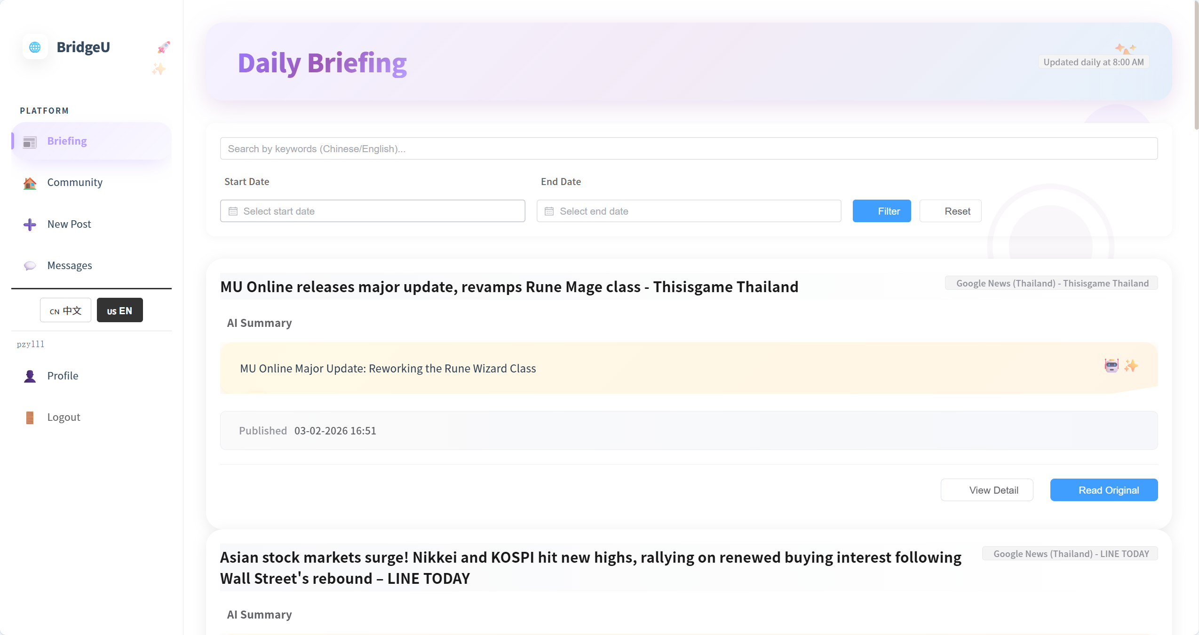

2. Observe that no search keyword, date filter, or source filter is selected (default state).

3. Verify that the page displays a list of 10 news items with titles, summaries, sources, publish dates, and actions (such as “View Detail” and “Open Original”).
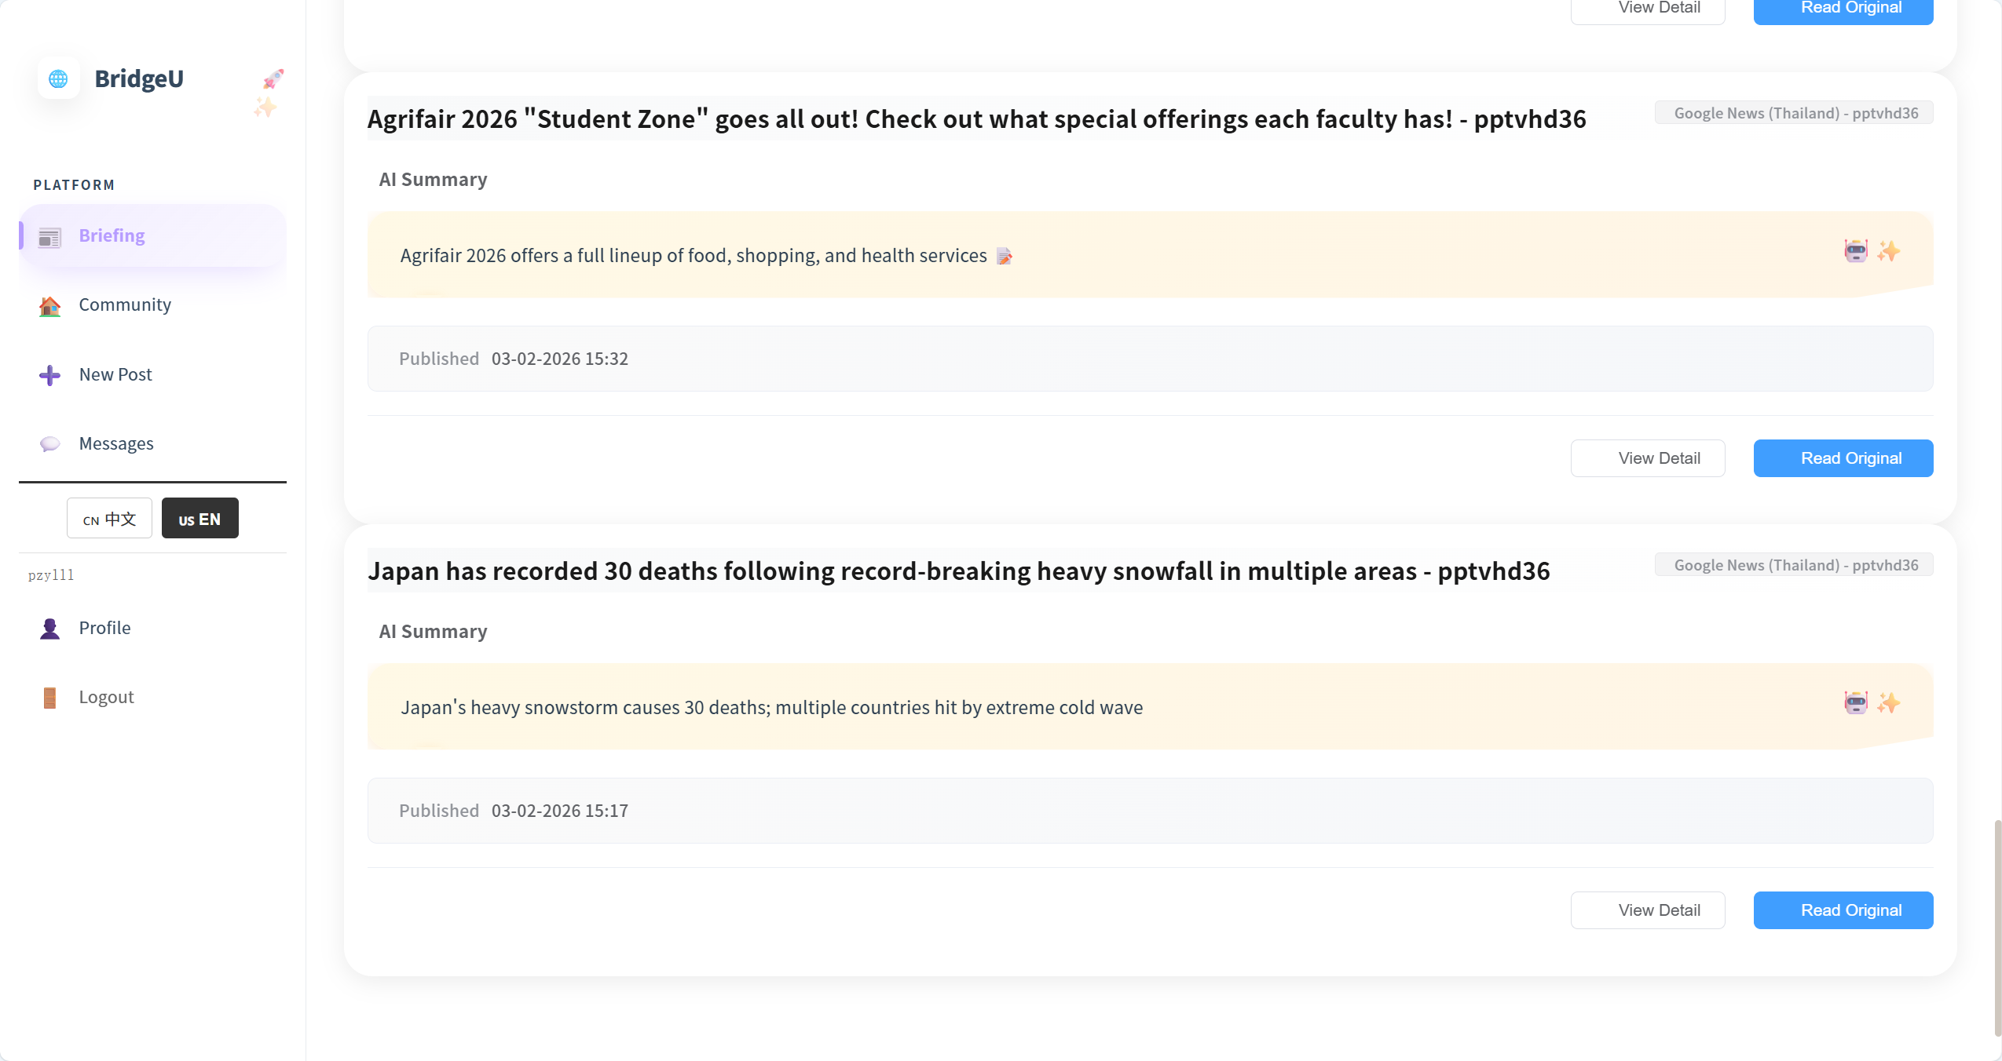

4. Verify that the pagination bar shows at least 2 pages when the total number of news records is greater than 10.
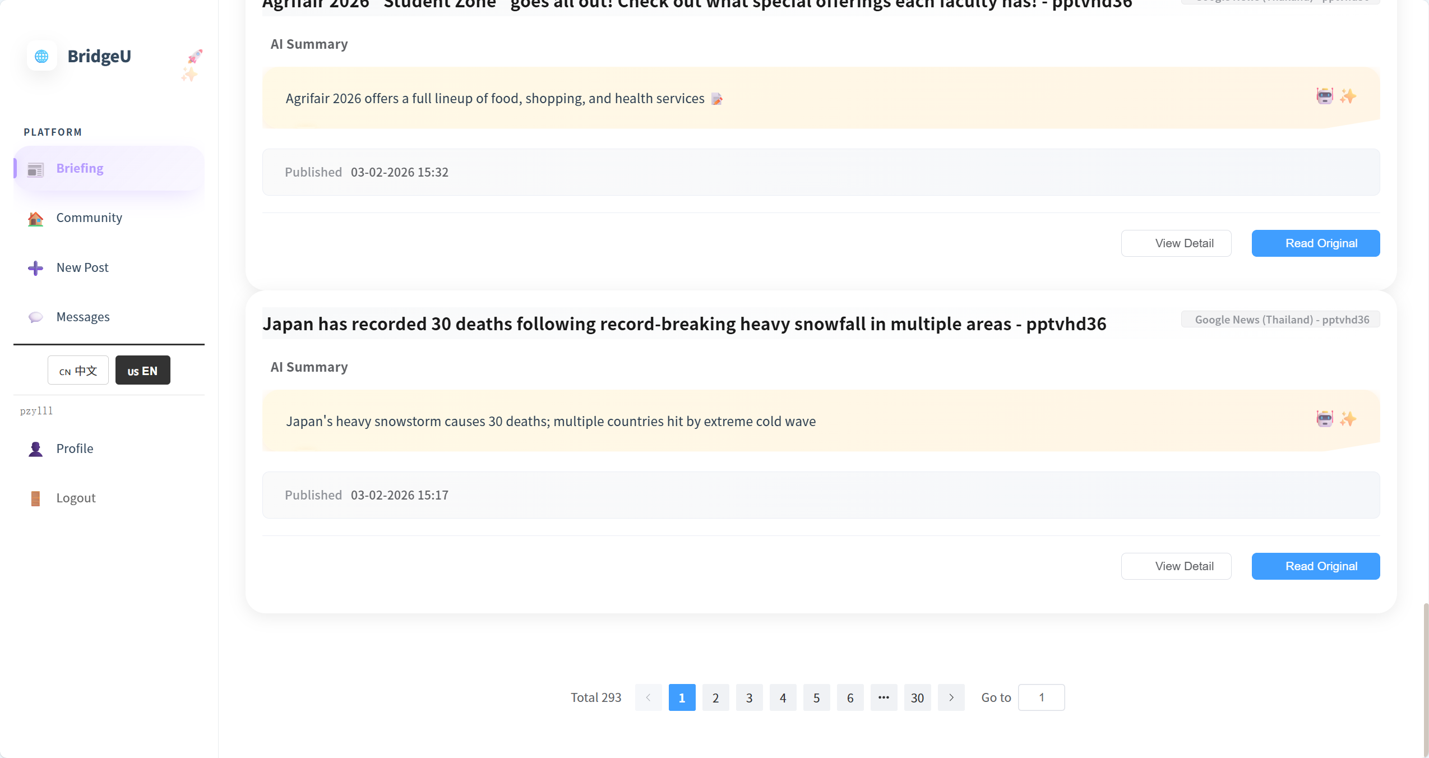
5. Scroll through all news items on the first page and verify that all visible titles and summaries are in Chinese or English only, with no Thai characters displayed.
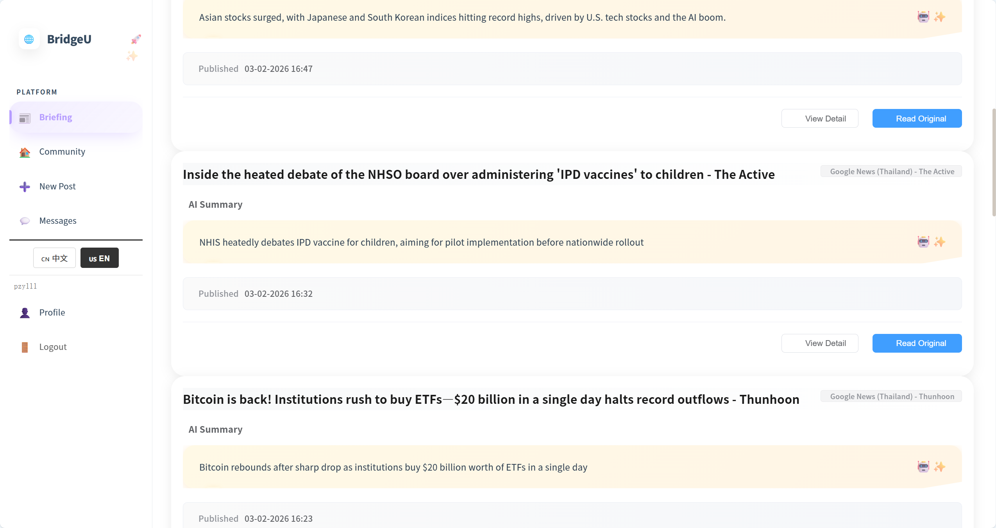

Test Case:

NO | Description | Input | Expected Result | Result
1 | Open Daily Briefing page with default state | Open BridgeU in a browser and navigate to “Daily Briefing” page with no filters applied. | Page shows 10 news cards with title, summary, source, publish date and actions; no search keyword, date or source filter is selected. | pass
2 | Verify pagination behaviour | Scroll to bottom of list. | Pagination bar shows at least 2 pages when total news records > 10. | pass
3 | Check UI language rule | Inspect all items on first page. | All visible titles and summaries are in Chinese or English only; no Thai characters appear anywhere in the list. | pass
4 | Click the "Briefing" button in the sidebar, and the button style will change | Click the "Briefing" button | The button changes from white to purple, and the color of the text changes from black to dark purple | pass

4.1.2 STC-02: Filter News by Date Range
Description: This system test verifies that the system correctly filters Daily Briefing news items by publish date range across frontend and backend.
Prepared Data:
Same environment as STC-01.
Database contains news items whose `publishDate` covers at least the last 30 days.
Test script:
1. Open the Daily Briefing page(UI-01) in the browser.


2. When user click the Select Date box, the calendar pops up
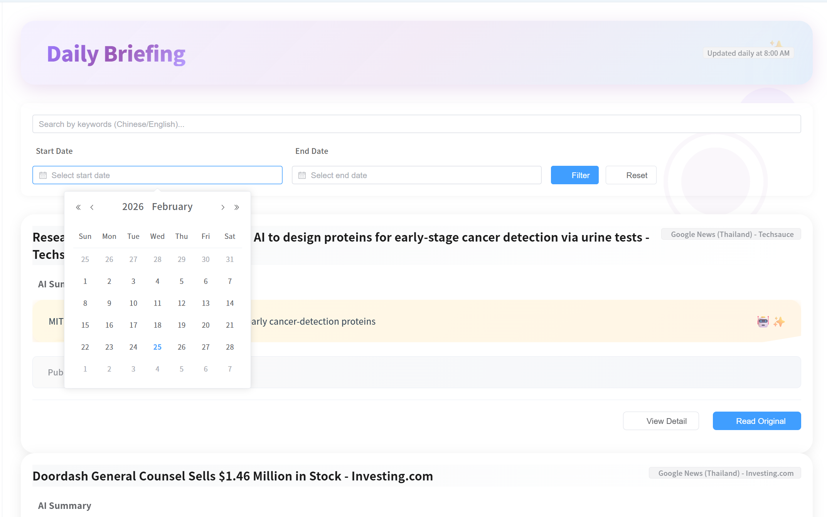
Test Case:
NO | Description | Input | Expected Result | Result
1 | Filter list by fixed date range | Set start date `01-01-2026`, end date `07-01-2026` and click “Apply Filters”. | Only news with a publication time between 01-01-2026 and 07-01-2026 is displayed in the list | pass
2 | Filter with only start date | Press “Reset” button, set start date `10-01-2026`, leave end date empty, click “Apply Filters”. | The press releases shown in the list are all after 10-01-2026 (inclusive) until the current date; There is no error message on the page, and the filtering takes effect successfully. | pass
3 | Filter with only end date and inferred start date | Press “Reset” button, set end date `20-01-2026`, leave start date empty, click “Apply Filters”. | System show start date as 30 days before `20-01-2026`; results only include news in this computed range. | pass
4 | Validate invalid date range | Set start date `10-02-2026`, end date `01-02-2026`, click “Apply Filters”. | Frontend shows validation warning (start date cannot be later than end date). | pass
5 | When you click the Select Date box, the calendar pops up | click the Select Date box | The calendar pops up, and you can click to select the date (day, month, year) | pass

4.1.3 STC-03: Search Daily Briefing by Keyword
Description: This system test verifies that keyword search works end-to-end, including parameter passing and search scope.
Prepared Data:
Same environment as STC-01.
Database contains news items whose `title`, `summary`, or translation fields (`titleZh`, `titleEn`, `summaryZh`, `summaryEn`) contain the keyword “Thailand”
Test script:
1. Open the Daily Briefing page(UI-01) in the browser.
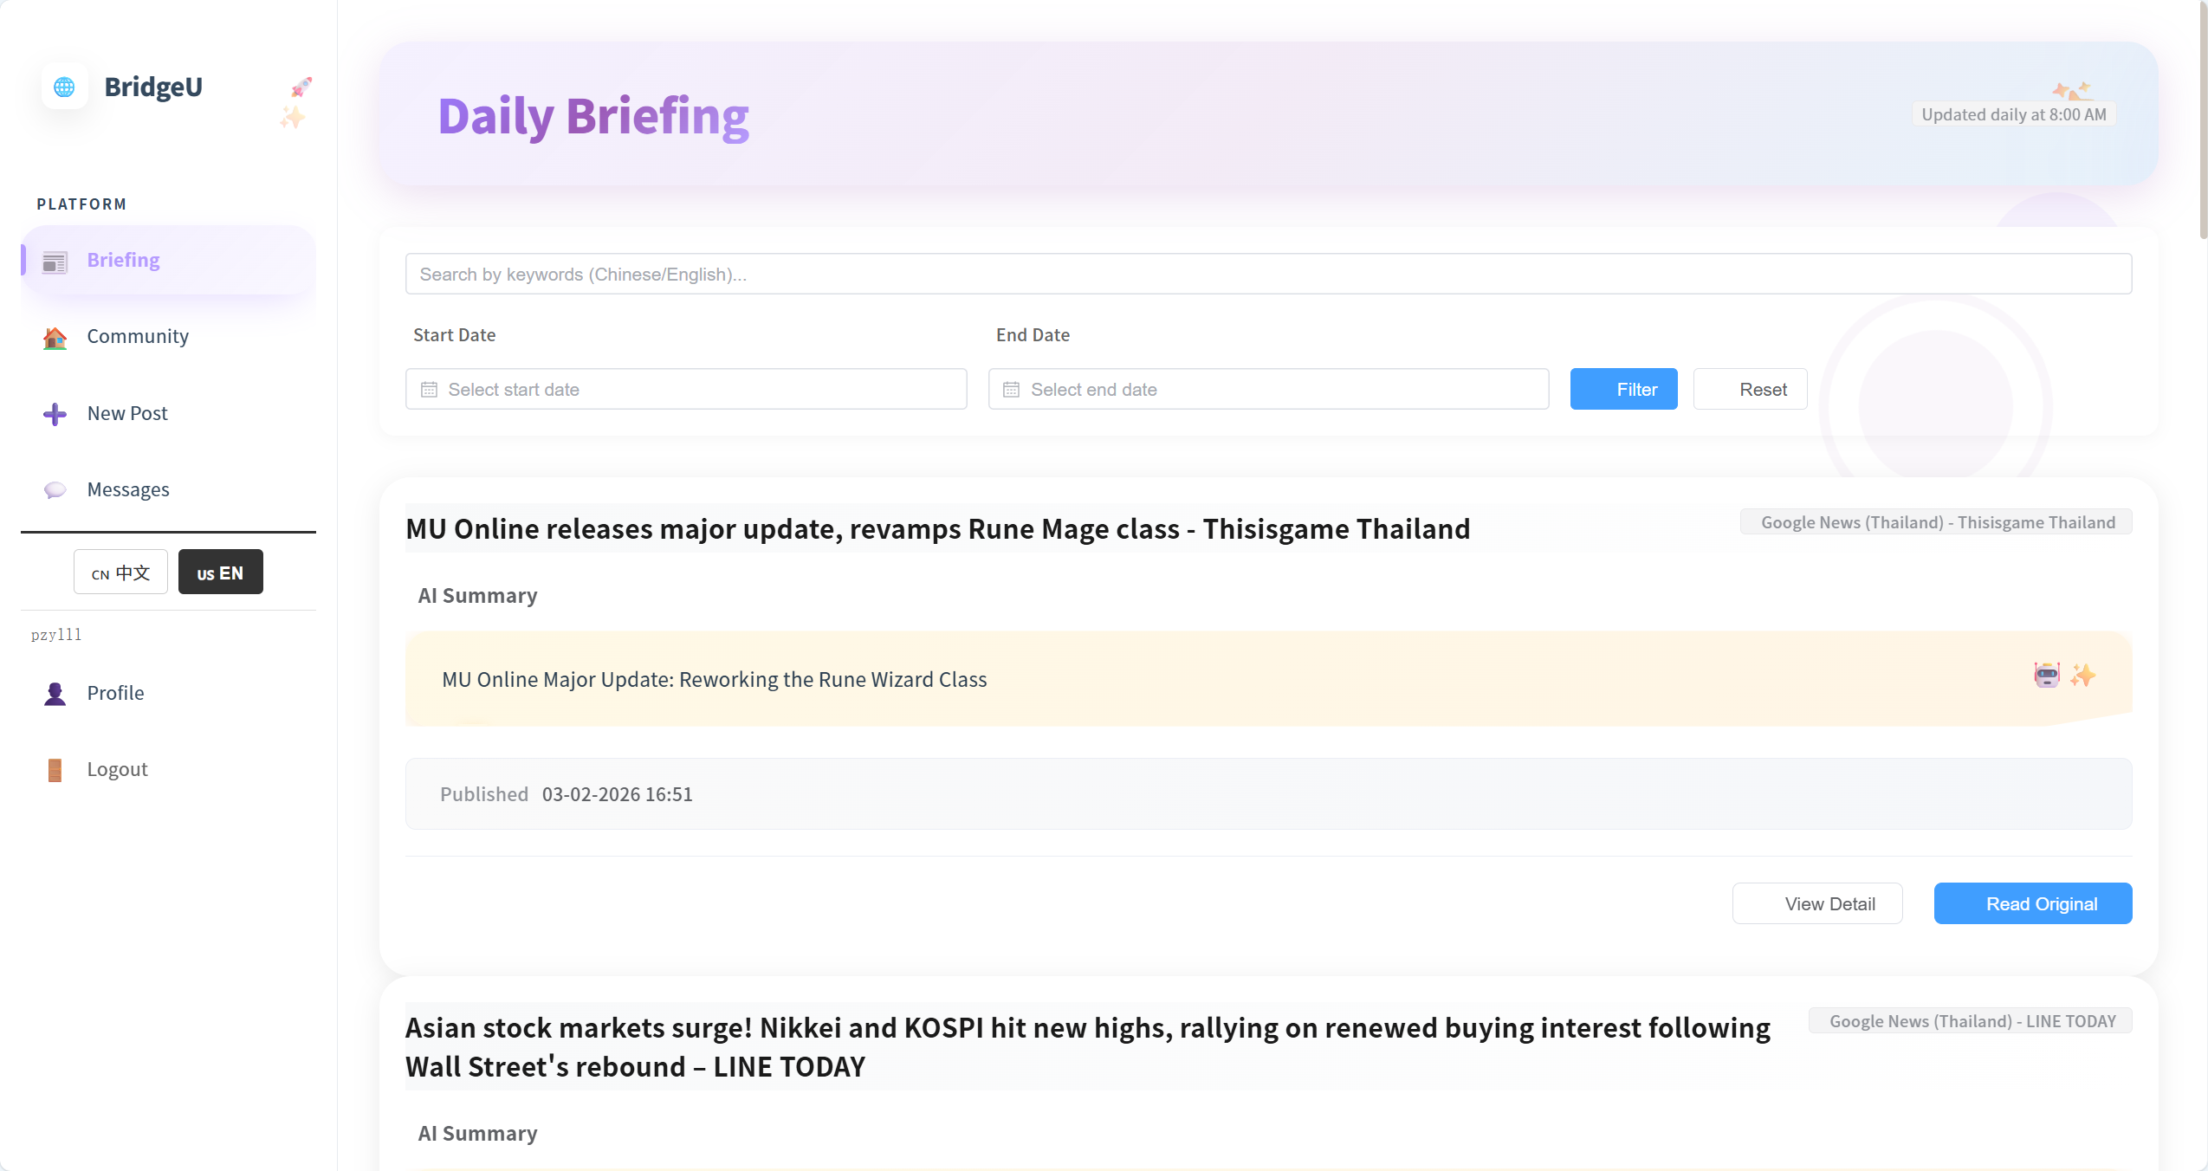

2. Optionally navigate to any page that already exists
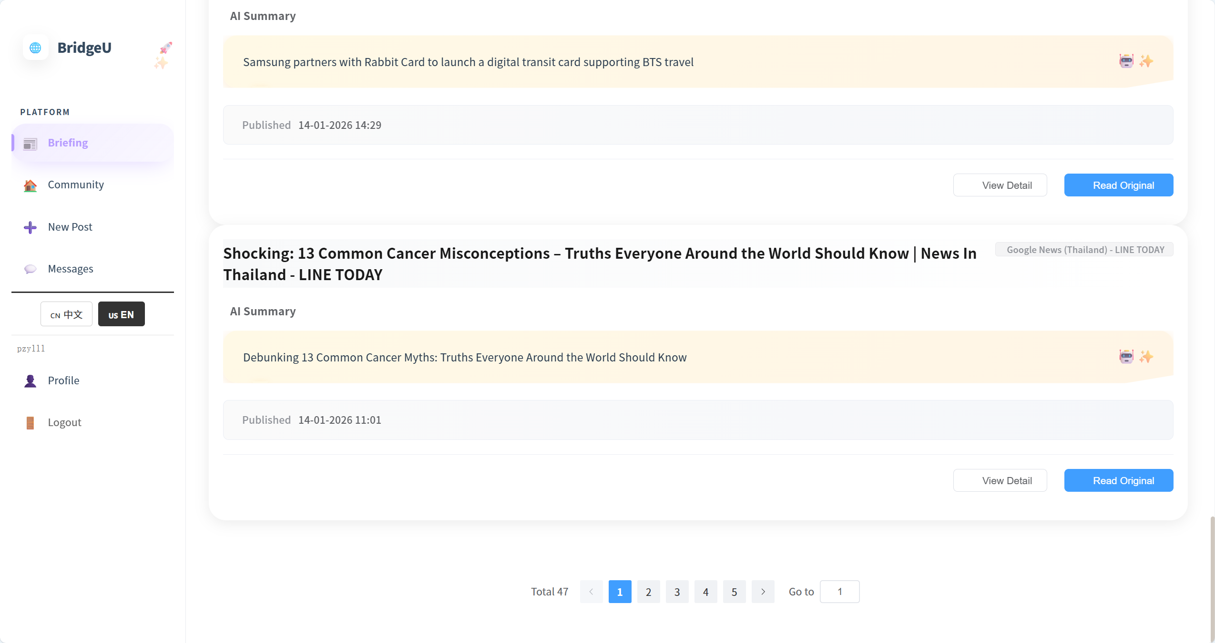

Test Case:
NO | Description | Input | Expected Result | Result
1 | Search by keyword | | Enter `Thailand` in search box and click “Filter” button. | UI resets current page to 1,returned list only contains news whose title, originalContent, summary or any translation field includes “thailand” (case-insensitive). | pass
2 | Clear keyword search | Clear search box and click “Search” again. | New request has no `keyword` parameter; list shows unfiltered results (respecting only any active date/source filters). | pass
3 | Combine keyword and date filters | enter `student`, set a valid date range, click “Search”. | Request includes both `keyword` and `startDate`/`endDate`; results only include items matching both the keyword and the date range. | pass
4 | Optionally navigate to any page that already exists | Enter page number “8” | The system will navigate to page 8 | pass
5 | Optionally navigate to any page that already exists | Click the number “4” | The system will navigate to page 4 | pass
6 | When click on a page number, the color changes | Click the number “4” | The color of the number 4 will change from black to blue | pass
7 | When the number page belongs, the number button on the bottom page changes from white to blue, and the number changes from black to white | Click the number “4” | The page 4, the number button on the bottom page changes from white to blue, and the number changes from black to white. | pass

4.1.4 STC-04: Switch Interface Language
Description: This system test verifies that switching between English and Chinese interfaces correctly reloads the Daily Briefing list using appropriate translations while still hiding Thai content.
Prepared Data:
Same environment as STC-01.
Database contains a dedicated test set of news records where “every record has both English and Chinese translations” (`titleEn`/`summaryEn` and `titleZh`/`summaryZh`).

Test script:
1.Ensure the interface language is set to “English (en)”, then open the Daily Briefing list.
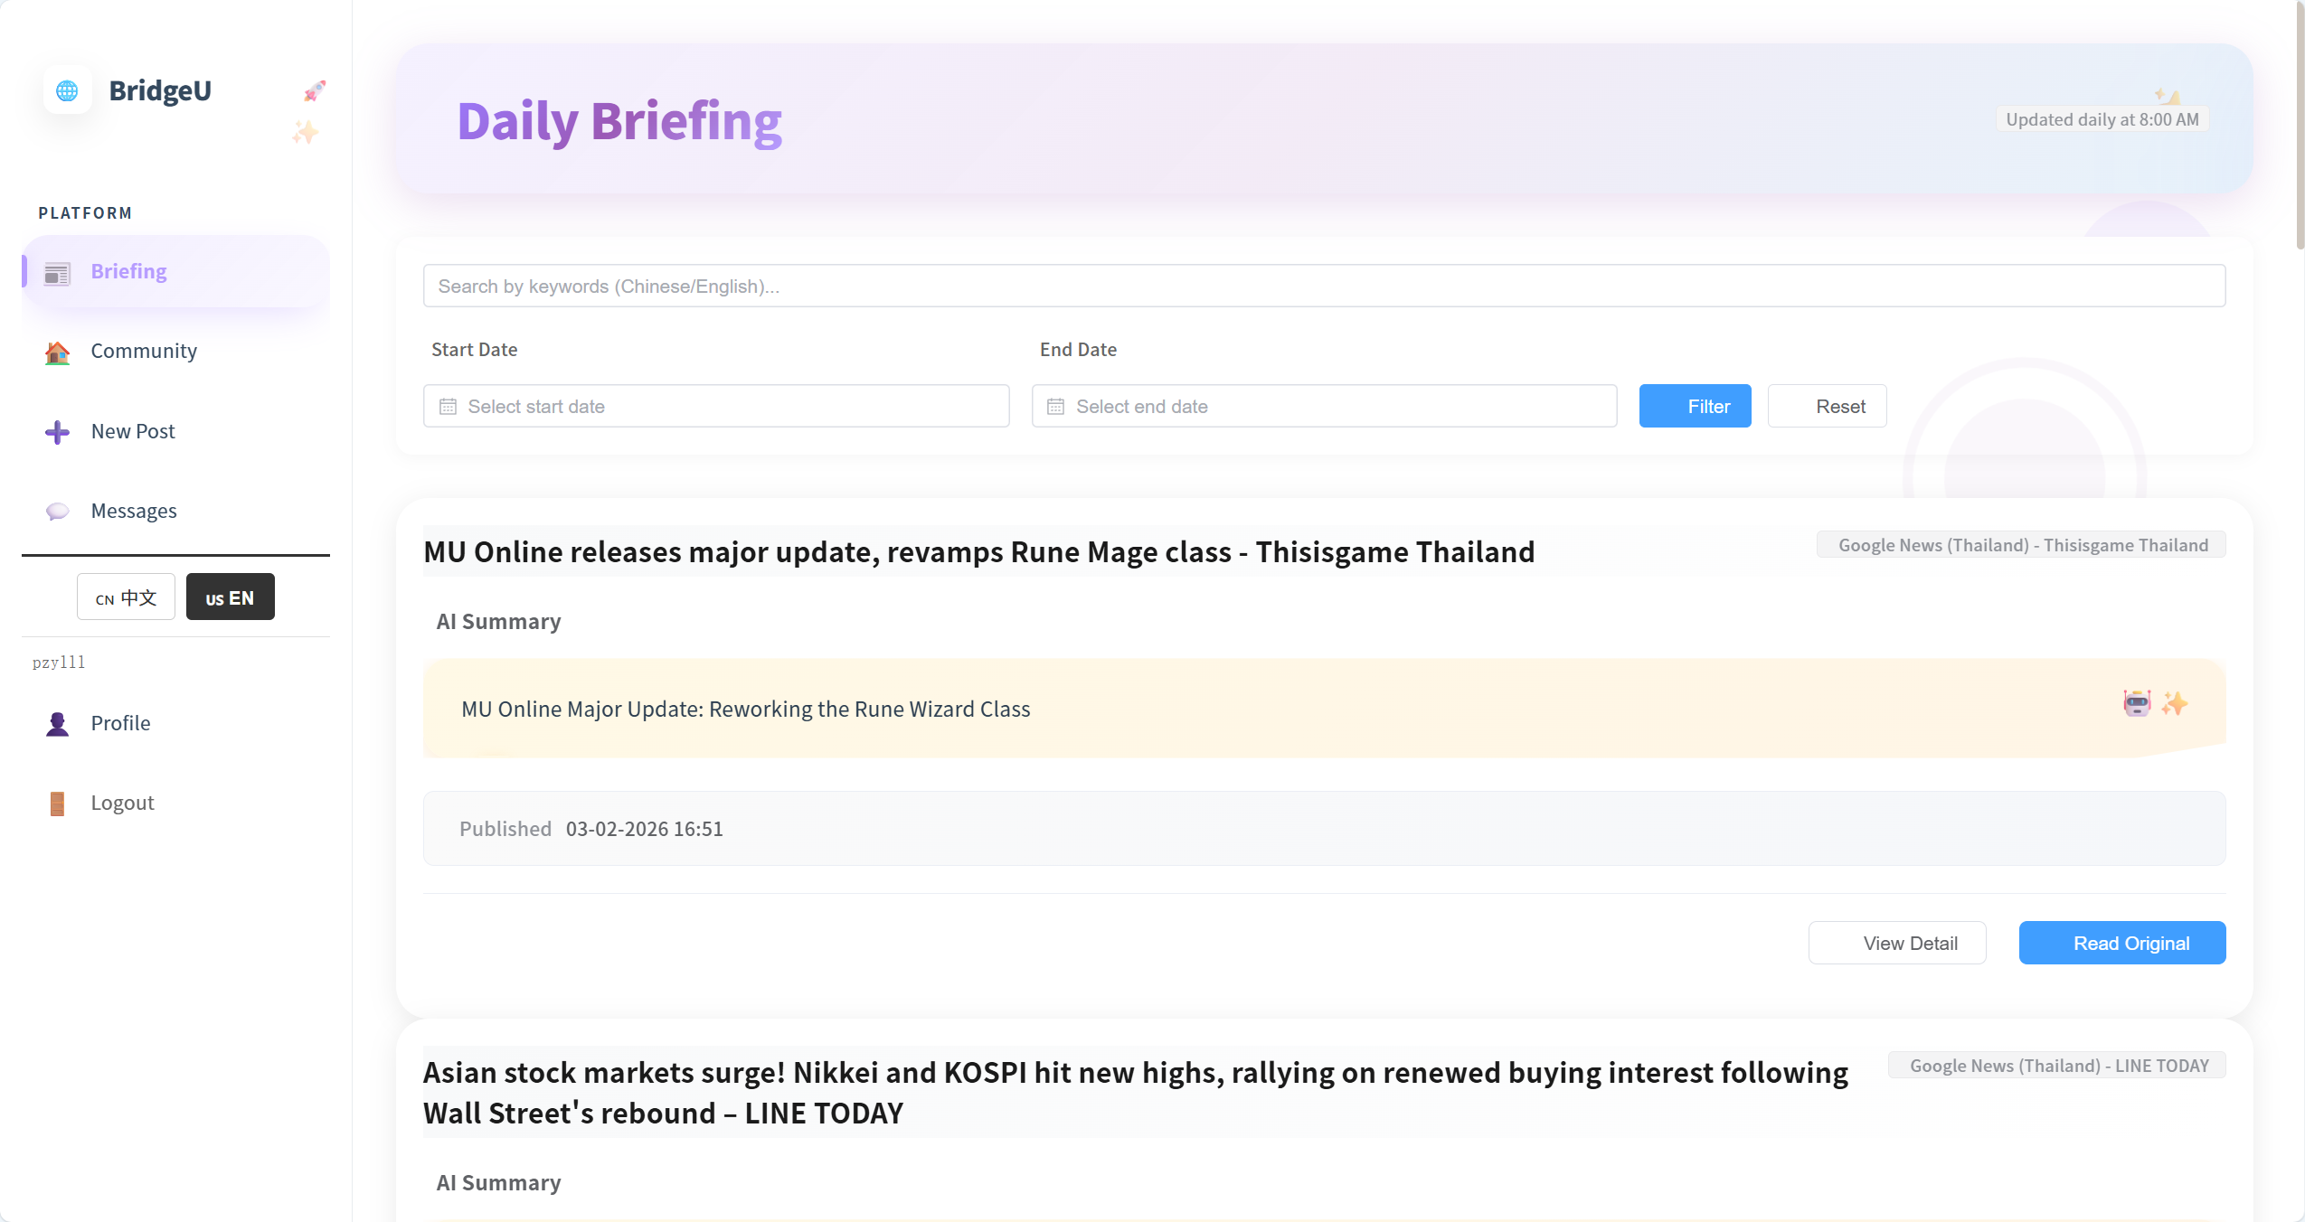

2.Use the language toggle in the UI to switch the interface language to Chinese (zh)
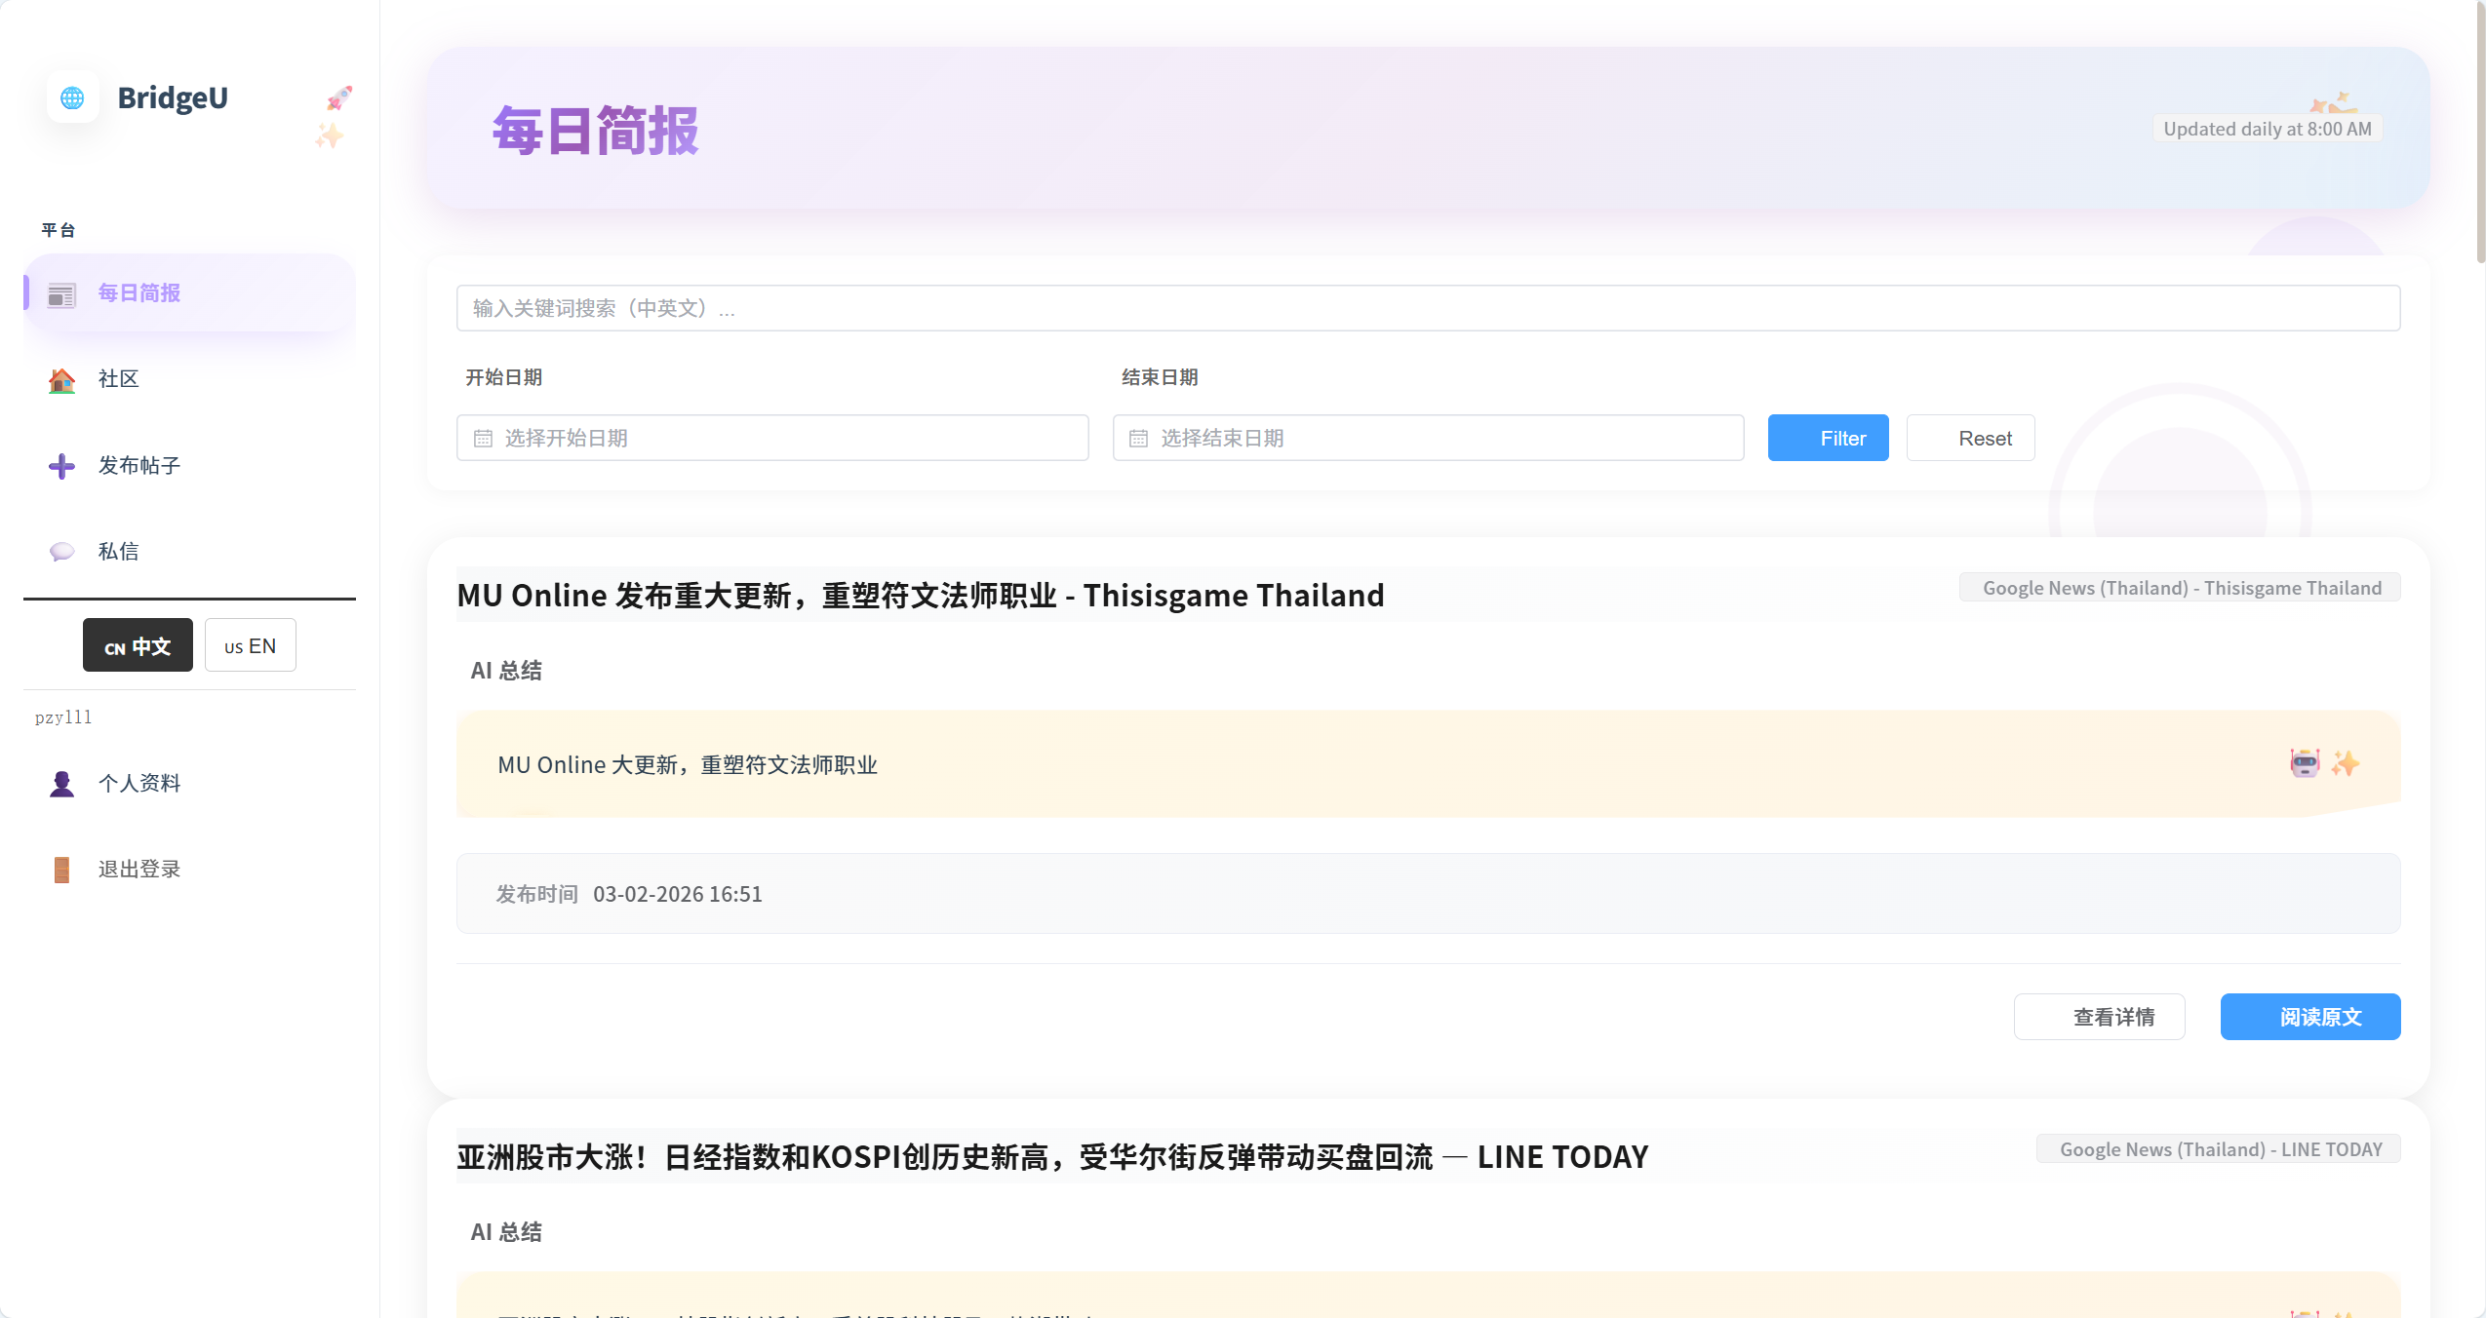

NO | Description | Input | Expected Result | Result
1 | Load list in Englis | Set interface language to `en`, open Daily Briefing list. | News list shows titles/summaries in English | pass
2 | Switch to Chinese | Use language toggle to switch to `zh`. | News list shows titles/summaries in Chinese | pass
3 | Button color changes | Click “usEN” | The button will change from white to black, and the words in the button will change from black to white | pass

4.1.5 STC-05: View News Detail
Description: This system test verifies that selecting a news item from the list opens the detail view and correctly retrieves full information from the backend, including rules for `originalContent`.
Prepared Data:
Same environment as STC-01.
Database contains at least one news record
Test script:
1. Open the Daily Briefing list and choose a news item , Click the “View Detail"action for this item.
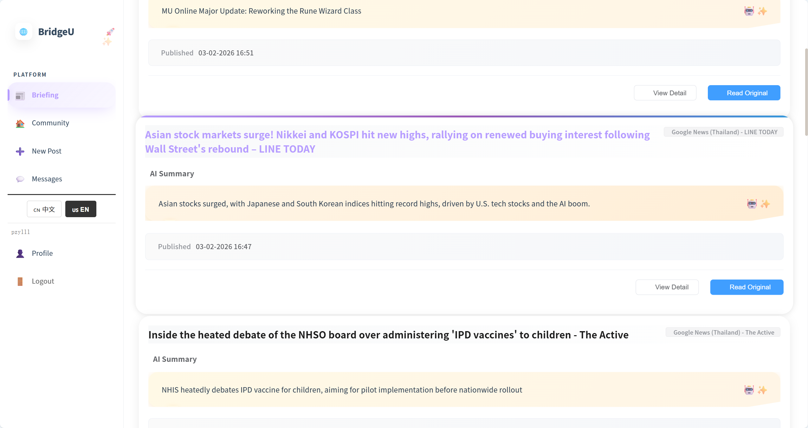

2. Confirm that the detail page displays only translated title/summary (or placeholders) and does not show any Thai original text.
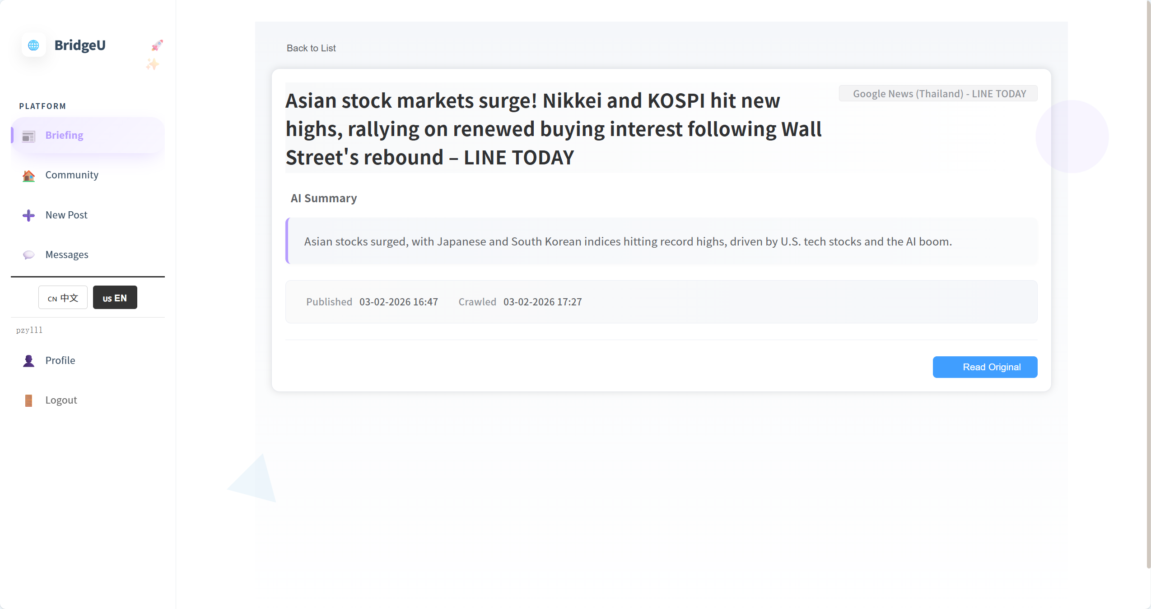
Test Case:
NO | Description | Input | Expected Result
1 | Open detail content | From list, click “View Detail” on news item | Detail page shows title, summary, source, publish date and original content section. |
2 | When the mouse hovers over the post, the style changes | The mouse hovers over the post | The post title changes from black to purple, the post outline becomes larger, and there is a gradient color bar at the top
3 | When click “View detail” button,the button style change | click “View detail” button | The button color changes from white to blue, and the font changes from black to dark blue

4.1.6 STC-06: Open Original News Link
Description: This system test verifies that the “Open Original” action correctly opens the original news article URL from backend data, both from the list and from the detail view.
Prepared Data:
Same environment as STC-01.
Selected news items have a valid `originalUrl` field in the database.
Test script:
1. Open the Daily Briefing list and find a news item that has a visible “Open Original” action.
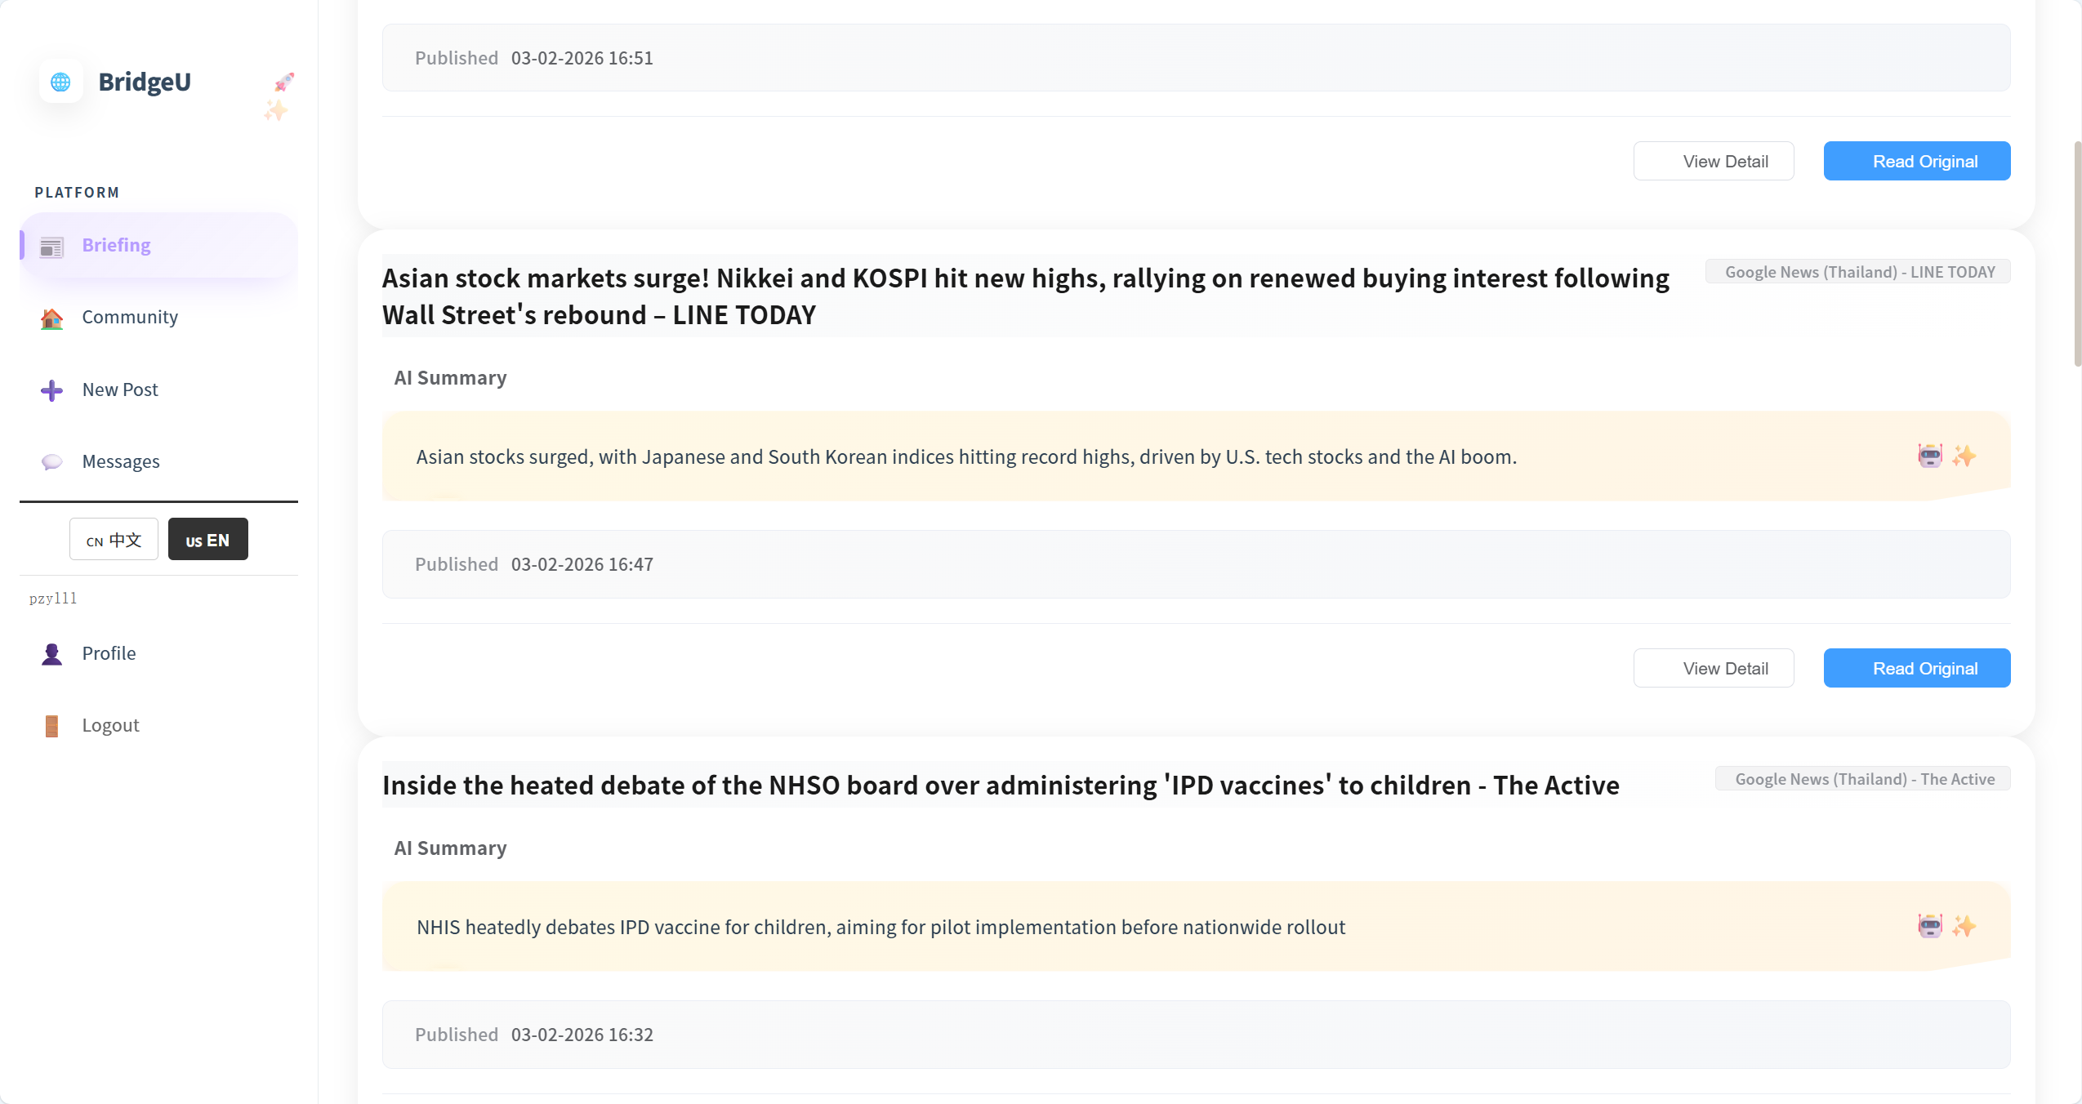

2. From the Daily Briefing list, click “View Detail” on the same news item to open the detail page.
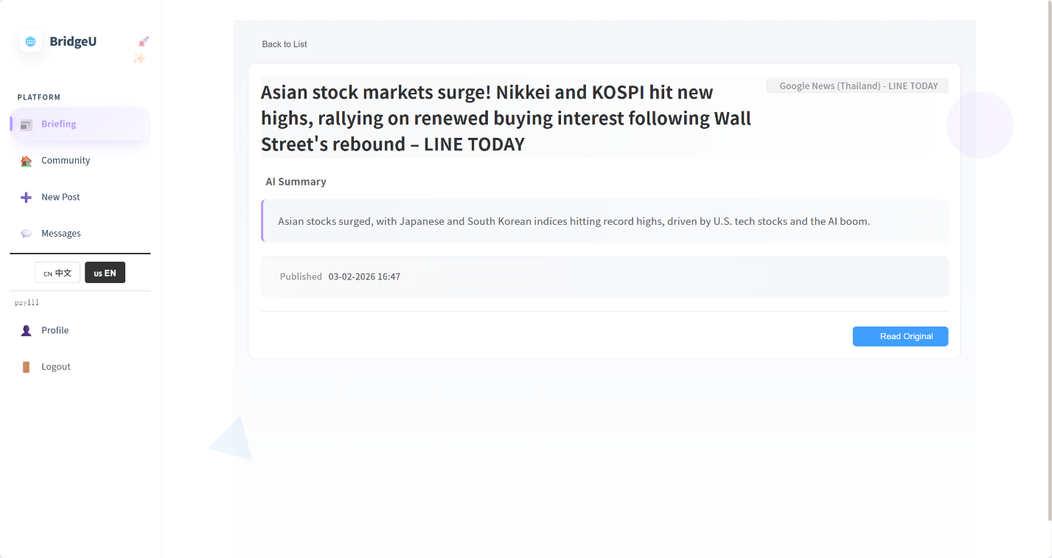
Test Case:
NO | Description | Input | Expected Result | Result
1 | Open original link from list | On Daily Briefing list, click “Open Original” for a news item with valid `originalUrl`. | Browser opens this news tab | pass
2 | Open original link from detail | From the same item, click “View Detail” then “Open Original” on detail page. | Browser opens this news tab | pass
3 | When click “Read Original” button,the button style change | click “Read Original” button | Button color and font lightened | pass

